**National University of Computer and Emerging Sciences**



Laboratory Manual

for

Data Structures Lab

|  |  |
| --- | --- |
| Course Instructor | Ms. Syeda Tayyaba Bukhari |
| Lab Instructor(s) | Fariha Maqbool |
| Section | BDS-3A |
| Semester | Fall 2022 |

**Department of Computer Science**

FAST-NU, Lahore, Pakistan

**Objectives:**

In this lab, students will practice:

1. Implementation of Max Heap Using Arrays

**Heap Data Structure**

Heap data structure is [a complete binary tree](https://www.programiz.com/dsa/complete-binary-tree) that satisfies the heap property, where any given node is

* Always greater than its child node/s and the key of the root node is the largest among all other nodes. This property is also called max heap property.
* Always smaller than the child node/s and the key of the root node is the smallest among all other nodes. This property is also called min heap property.

**Question 1:**

1. **Now create a MaxHeap class which contains:**
2. A pointer to array of elements “arr”
3. An int variable “capacity” which stores the total capacity of heap.
4. An int variable “size” which stores the current number of elements in heap

It should have following member functions:

1. A default constructor which assigns nullptr to arr pointer. MaxHeap()
2. An overloaded constructor which takes as argument the value of capacity and allocates the memory of the required capacity to arr pointer. MaxHeap(int _capacity).
3. A recursive function **checkMaxHeap()** that takes an array as argument and check if the array is representing the max heap or not
4. A **Heapify()** function that converts an array to a Max Heap
5. An **insert**() function which takes as argument a value. It then inserts the value in the heap array such that, the resultant heap tree is a complete binary tree and it follows max heap ordering. If totalItems==capacity, then double the capacity of heap array and insert the value. There must not be any memory leaks. void insert(int value)
6. A **print()** function that prints the heap
7. A **getMax** function that returns the maximum value from heap
8. A **getKthMax** function that returns the kth maximum value from heap

**For example:** If k=2, kth largest will be 50

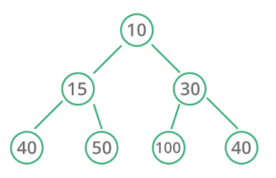

1. A **MergeHeaps()** function which takes two heap arrays as argument and merge them to create a new heap. To implement this function you have to:
   1. Create a new array
   2. Copy both heaps elements into new array
   3. Build Max heap of this new array
   4. Print the new array
2. Create a function which returns the max number of possible swaps to heapify the Kth Node of Heap.

**For Example: If K = 10, then max possible swaps to heapify 10 is 3.**

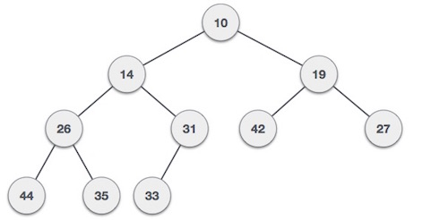

1. destructor